Civil war in Somalia

UNSC Resolution: | 733
Date of adoption: | 23-Jan-1992
Operative paragraph: | 4
Demand number: | 733,0411

Sarah-Myriam Martin-Brûlé

Wording of demand

Immediately cease hostilities and agree to a cease-fire and promote the process of reconciliation and of political settlement in Somalia

List of addressees of the demand

Government of Somalia, United Somali Congress Faction

Short-term compliance

Immediately cease hostilities and agree to a cease-fire

“A cease-fire was agreed upon in early March, and despite frequent but short-lived breaches, a fitful peace in Mogadishu has been in effect for almost one year.”

Human Rights Watch Report on Somalia. “Beyond the Warlords: The Need for a Verdict on Human Rights Abuses”, March 7, 1993. Vol. V. No.2.
http://www.hrw.org/legacy/reports/1993/somalia/ (page consulted on August 10th 2009)

“Early mediation efforts had limited success but did secure agreement on a cease-fire between the leaders of two major factions, General Aideed and Ali Mahdi, and the deployment of a UN technical team.”

Murphy, Ray. 2007. UN peacekeeping in Lebanon, Somalia and Kosovo: Operational and Legal Issues in Practice. Cambridge University Press, p. 49

Pursuit of hostilities:

Description of the addressee(s)’ conduct
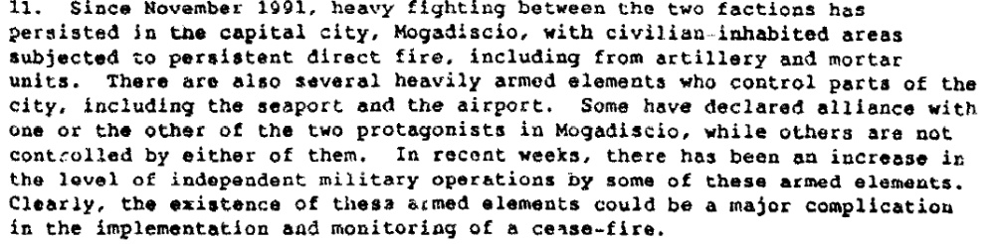

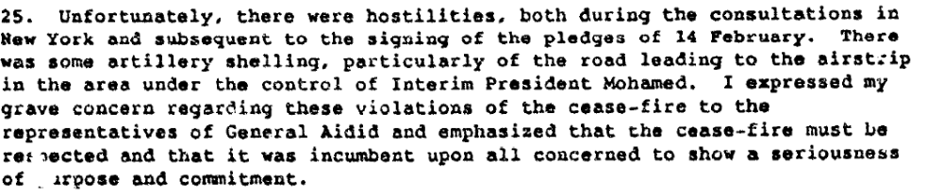

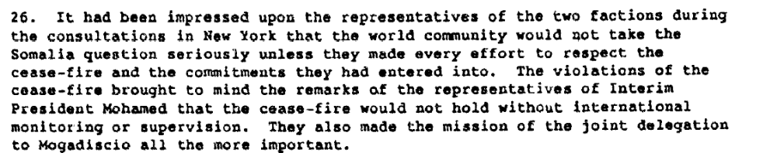

Report of the Secretary General on the Situation in Somalia, 11 March 1992 S/23693, p.7
http://daccessdds.un.org/doc/UNDOC/GEN/N92/109/47/PDF/N9210947.pdf?OpenElement

agree to a cease-fire and promote the process of reconciliation and of political settlement in Somalia

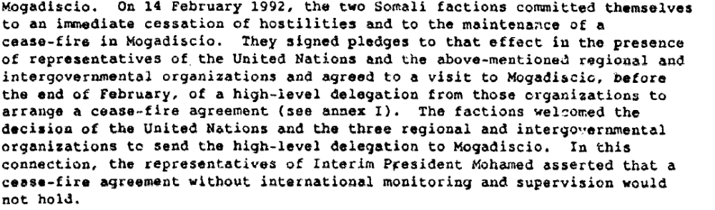
Report of the Secretary General on the Situation in Somalia, 11 March 1992 S/23693, p. 6
http://daccessdds.un.org/doc/UNDOC/GEN/N92/109/47/PDF/N9210947.pdf?OpenElement

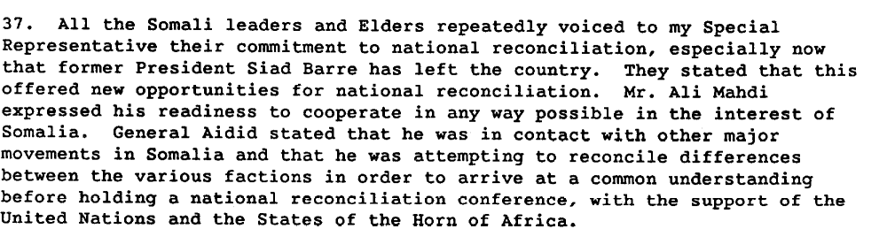

Report of the Secretary General on the Situation in Somalia, 22 July 1992 S/24343.
http://daccessdds.un.org/doc/UNDOC/GEN/N92/109/47/PDF/N9210947.pdf?OpenElement

“General James Jonah's January 1992 mission to Mogadishu. U.N. efforts to broker a ceasefire between General Aideed and Ali Mahdi not only aggravated tensions between the rival clans but also eroded the neutral positions of other clans as well as that of the United Nations. That failure helped extend civil war for another two months and even today undermines U.N. credibility as it attempts to arrange a lasting peace. Other U.N. failures also exacerbated tensions and violence among Somali factions. A high-profile U.N. delegation headed by Special Coordinator Brian Wannop in February 1992 failed to invite other clan leaders and elders to participate in discussions with Aideed and Ali Mahdi over peace talks proposed to be held in New York. The lack of perceived standing made it easier for Ali Mahdi to launch attacks against smaller clans, which he did the day after the United Nations issued invitations. Another Jonah mission to Mogadishu in February finally led representatives of Aideed and Ali Mahdi to convene at U.N. headquarters in New York under the auspices of the United Nations, the Islamic Conference, the Organization of African Unity and the Arab League.”

Clark, Jeffrey. “Debacle in Somalia” Foreign Affairs, Vol. 72, No. 1, America and the World 1992/93 (1992/1993), pp. 109- 123
http://www.jstor.org/stable/pdfplus/20045500.pdf

“Later in February 1992 talks were held between the warring factions in New York under the auspices of the UN, the League of Arab States, the Organization of African Unity, and the Islamic Conference. The UN showed signs of a more active role in resolving the problem. Although a cease-fire agreement was signed, the fighting continued.”
http://www.dtic.mil/cgibin/GetTRDoc?AD=ADA406495&Location=U2&doc=GetTRDoc.pdf

“On February 12, the Mahdi and Aidid groups met with a range of officials at UN headquarters in New York but never together. (…) The Aidid and Mahdi delegations gave their assurances that they would work toward a cease-fire by signing an ambiguous cease-fire agreement.”

Rutherford, Kenneth. 2008. Humanitarianism Under Fire: The US and UN Intervention in Somalia. Kumarian Press P. 23

“Aidid and Mahdi swiftly re-established the cease-fire, resulting in relative peace and little fighting in Mogadishu for several weeks.”

Rutherford, Kenneth. 2008. Humanitarianism Under Fire: The US and UN Intervention in Somalia. Kumarian P. 24.

“As the international community brought in more aid, armed gangs started to skirmish with each other, eventually waging outright warfare throughout Mogadishu area and drawing in Aidid and Mahdi forces interested in protecting their territories. Several weeks after the March agreement, fighting levels were above pre-agreements levels as the Aidid and Mahdi forces joined the fray and resumed fighting each other and the armed gangs.”

Rutherford, Kenneth. 2008. Humanitarianism Under Fire: The US and UN Intervention in Somalia. Kumarian P.24.

“Following Jonah’s return to New York, Boutros-Ghali, with Security Council support, invited the two faction leaders to send delegations to New York to discuss a cease-fire. Aideed and Ali Mahdi accepted (…). An enormous number of shells were lobbed into north Mogadishu from Aideed’s south side while these discussions dragged on. Still, on February 14 representatives of the two sides agreed in principle to a cease-fire.”

Rutherford, Kenneth. 2008. Humanitarianism Under Fire: The US and UN Intervention in Somalia. Kumarian P.24.

Assessment

Short-term compliance
No or marginal compliance (1) | X Medium low compliance (2) | Medium high compliance (3) | Full or almost full compliance (4)

Considerations underlying the assessment

Medium low compliance given that although the parties agreed to a cease-fire in the short term, hostilities were not ceased immediately, and there were no significant promotion of the process neither of reconciliation nor of political settlement by the parties.

Medium-term compliance

Description of the addressee(s)’ conduct

He reported that heavy fighting had persisted in Mogadishu since November 1991. The fighting had resulted in widespread death and destruction, forced hundreds of thousands of civilians to flee the city,
caused dire need for emergency humanitarian assistance, and brought about a grave threat of
widespread famine. It had also seriously impeded United Nations efforts to deliver much-needed
humanitarian assistance to the affected population in and around Mogadishu

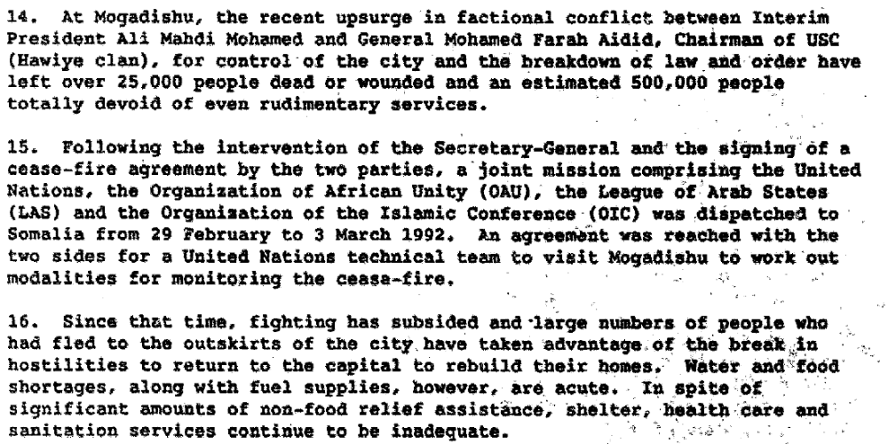

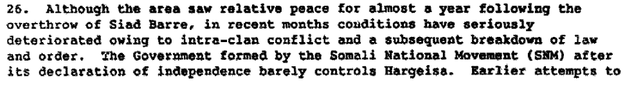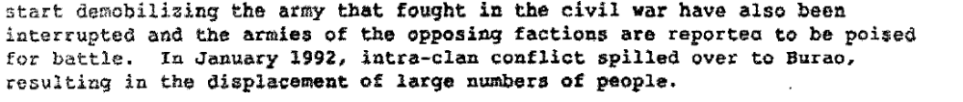

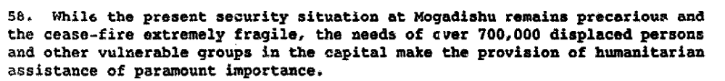

Report of the the United Nations Secretary-General on Situation in Somalia, Addendum, 21 April 1992
\23829\Add. 1

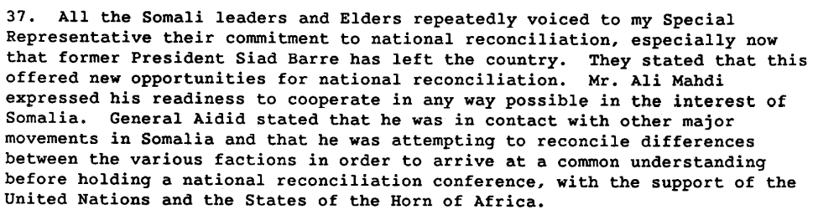

Report of the United Nations Secretary-General on Situation in Somalia, 22 July 1992 \24343).

Assessment

Medium-term compliance
X No or marginal compliance (1) | Medium low compliance (2) | Medium high compliance (3) | Full or almost full compliance (4)

Considerations underlying the assessment

There were no or marginal compliance by the belligerents since the fighting resumes, and that the level of violence reached unprecedented levels.

Depth of demand

Assessment

Level of depth of demand
Low depth of demand (1) | X Medium depth of demand (2) | High depth of demand (3)

Considerations underlying the assessment

“Although any agreement on a cease-fire was welcome, the pact in question was vague in some crucial respects. In particular, it was unclear as to the warring factions included and left most of the country unaffected. It also had the unintended effect of focusing on Mogadishu to the detriment of the remainder of the country and it may have even intensified the rivalry for control between Aideed and Mahdi in the city. As parties to the agreement, it allowed each to claim legitimacy through dealing with the UN.

Murphy, Ray. 2007. UN peacekeeping in Lebanon, Somalia and Kosovo: Operational and Legal Issues in Practice. Cambridge University Press, p. 50

The demand did not jeopardize the survival of either group, yet it implied significant sacrifices in terms of power over the population, territory, resources for each of them.

Level of confidence about coding decisions

Level of confidence about coding decision
Extremely high | X High | Moderate

Comments to IPI (if any)

